Our School Uniform

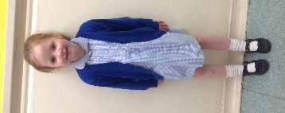
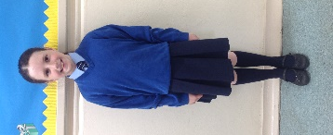
Girls
- Navy skirt, pinafore, trousers
- Blue blouse
- Navy/white striped tie*
- Royal blue V-neck pullover or cardigan
- Navy knee socks/tights
- Summer-blue/white checked summer dress

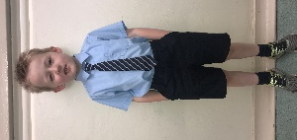
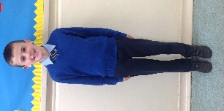
Boys
- Navy trousers
- Blue shirt
- Royal blue V-neck pullover
- Navy/white striped tie*
- Summer –navy shorts
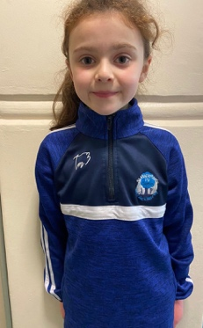

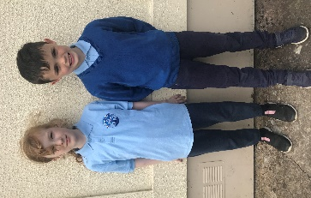
P.E. Uniform
- Plain navy tracksuit bottoms
- Blue polo shirt with school crest
- ¼ zip hoodie with crest (order through school)

*available in school

