Ditch the Dark Day!

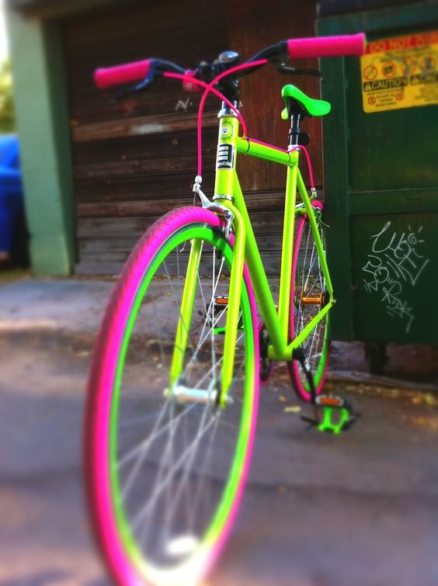

A special cycle, scoot and walk to school day – you are invited to wear your brightest clothes and accessories AND to brighten up your bike or scooter!
Friday 25th November 2016
Brilliant PRIZES for the best and brightest outfits, bikes and scooters!

