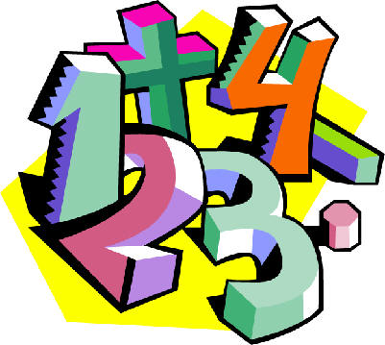 P.3/4 Class Rap!!

Maths Maths, 1 2 3,
Come and play some Maths games with me!

Maths Maths, 4 5 6,
Let’s go do some mental maths tricks.

Maths Maths, 7 8 9,
Don’t forget to use your number line!

Maths Maths, we’ve counted to 10,
Off we go to London to visit Big Ben.

